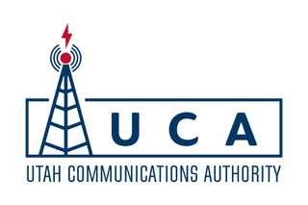

Public Notice of the Meeting of the

Utah Communications Authority’s

Public Safety Advisory Committee (PSAC)
Date: Wednesday, September 11, 2024
Time: 9:00 am
Join the meeting now
Meeting ID: 215 679 524 154
Passcode: ahh4Px
+1 469-909-2290
Phone conference ID: 634 012 895#
Anchor Location:
5215 Wiley Post Way #550
Salt Lake City, UT 84116

- Welcome;
- Roll Call;
- Approval of Meeting Minutes from August 7, 2024;
- P25 Project Update;
- Round Table Discussion;
- Motion to Adjourn. Next Meeting Date.

